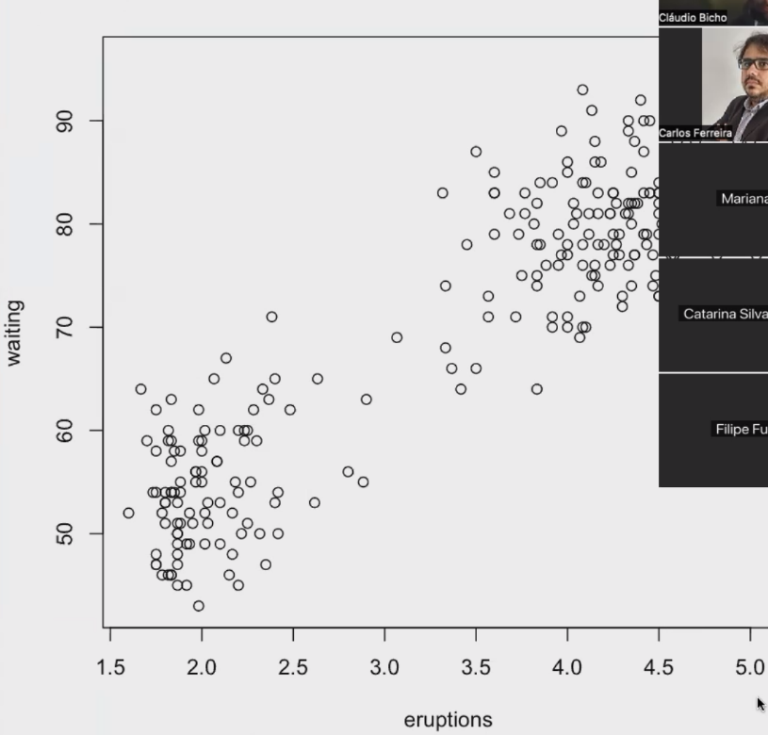
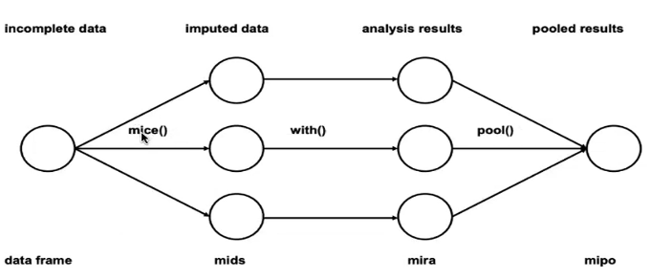
E-step
ptilde1 <- p*dnorm(y, mean = mu1, sd = sigma1)
ptilde2 <- (1 - p)*dnorm(y, mean = mu2, sd = sigma2)
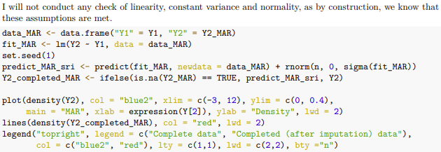
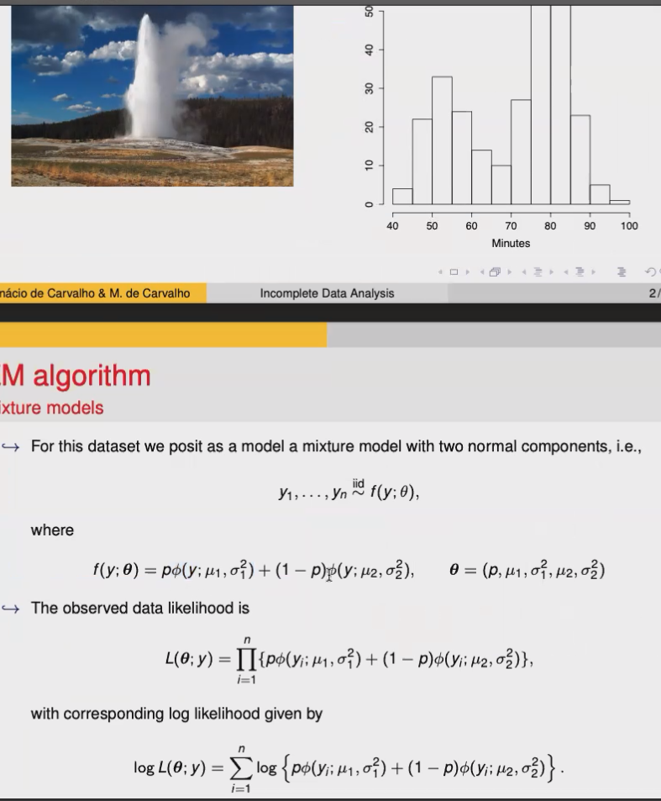
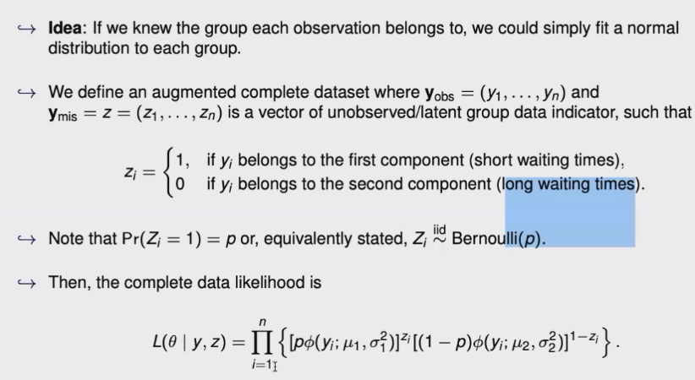
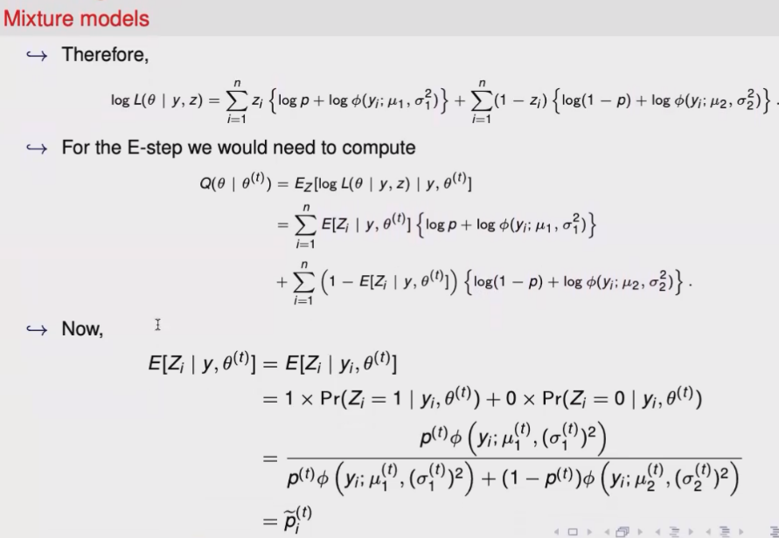
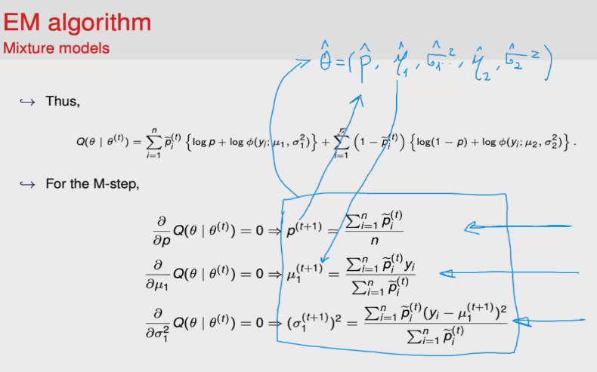
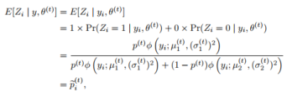
ptilde <- ptilde1/(ptilde1 + ptilde2)
Time between Old Faithful eruptions

